Rental Event Details
RENTER DETAILS
Name:______________________________________________________________________________________________________
Telephone: __________________________________________________________________________________________________
Email: ______________________________________________________________________________________________________
Mailing Address: _____________________________________________________________________________________________
Description/Type of Event:______________________________________________________________________________________
Type of I.D Provided: License:___ Passport:___ Other:__________________________________________
*Please attach a copy of the I.D of choice (Picture, scan, etc)
Rental Fees | Notes | Fee | Total
Full Day | Full calendar day (no other bookings can be made)  Non-Resident of York = $200.00  Resident of York = $75.00 | $200.00 or $75.00

Additional Fees *may be determined per the discretion of the CAO or Mayor
Damage Deposit | To be applied to all bookings. Refundable after inspection | $300.00

Total

Renter/Representative Initial to Acknowledge Fees: INITIAL: _________

Notes: ____________________________________________________________________________________________________________________________________________________________________________________________________________________________________________________________________________________________________________________________________________________________________________________________________________________________________________________________________________________________________________________________________________________________


THIS RURAL MUNICIPALITY OF YORK FACILITY RENTAL AGREEMENT
made as of
___________________________________________
Date
BETWEEN: THE RURAL MUNICIPALITY OF YORK
(The Municipality)
AND

__________________________________________________
(The Renter)

Whereas the parties have agreed the Municipality is responsible for scheduling and maintaining Hall facilities and the Renter wishes to use York Community Hall, the parties hereby agree to the following:

The RENTER shall be responsible for:
- Payment to secure the hall rental booking is due in full upon signing of the rental agreement.
- Person(s) renting the hall as a “Resident” will provide a valid document to act as proof of “Resident” status.
- All Renters will provide a valid government issued I.D that matches the provided address outlined in the “Rental Details Page” or if the address is different, will provide a document/bill to accompany the government issued I.D with corresponding address.
- Contacting the Facility Booking Scheduler at 902-629-5961 if equipment is out of place or damage is visible prior to commencement of booking.
- This Agreement may be terminated prior to the scheduled function by The Renter or by The Municipality given that notice is provided by telephone and/or e-mail and at least 72 hours prior to the rental date. Failure to do so will result in a forfeit of the full rental amount. All cancellations within the 72 hours with provided reason is at the discretion of the CAO/Mayor.
- The renter will respect the surrounding neighbors and adhere to the Curfew/No Noise times as follows: Sunday-Thursday being 11pm, Weekends (Friday & Saturday) being 1am.
- The Renter shall be responsible for ALL Municipality property during the period of the rental and shall pay for any damage, breakage, theft or defacing of or to Municipality property occurring during or as a result of the rental.
- The Rural Municipality of York is not liable for any damage to or loss of any property brought into the Premises in conjunction with the rental type by the Renter/Group named hereon or their members, officers, employees, agents, or contractors or any person who attends the function.
- The renter shall indemnify and hold harmless “The Municipality,” its agents, its representatives, its suits and any other expenses of any sort or at any time arising out of the function, caused in whole or in part by any negligent act or omission of the Renter, his agents, employees, volunteers or anyone directly or indirectly employed by any of them or anyone for whose acts they are responsible or may be liable.

- The renter shall adhere to regulation specified by the Provincial Fire Marshall, the Liquor Control Commission and The Municipality’s bylaws and regulations. Fire regulation states the maximum occupancy in the Community Hall is listed as ________ with NO EXCEPTIONS.
- The renter shall supervise and be in control of ALL persons in attendance at the function and to restrict persons to the premises, as required.
- The renter is responsible for ensuring that all persons in attendance at the function observe the parking availability and restrictions as per the diagram presented in Appendix A to this Facility Rental Agreement.
- The setup and take-down of any equipment; equipment is expected to be cleaned/disinfected and stored neatly as before rental occurred.
- All equipment, decorations, etc. must be out of the facility before the renter leaves the premises on the booking date. The Municipality will not be responsible for any equipment or decorations left behind after the booking. The renter is responsible for any damage caused to the walls.
- The Renter(s) using the kitchen area are also responsible for ensuring all counters and cooking surfaces are wiped down, all dishes used are washed, dried and stored, and all appliances (e.g., coffee maker, kettle) are unplugged and floors swept. If these basic cleaning/tidying responsibilities outlined in Appendix B are not fulfilled by the Renter, the Municipality reserves the right to retain the damage deposit fee that was initially collected upon signing of the rental agreement.
- Decorations – No decorations, temporary fixtures, or any materials, or applications that may cause irreversible damage may be affixed to the walls and or ceilings of the facility that requires the use of adhesives, nails, tacks, staples, tape, or certain types of paint. Renter is responsible for all repairs if damage should occur.
- Any infraction to the above conditions, particularly in regard to Provincial fire, Liquor Commission and Municipality Bylaws and Regulations, shall result in suspension of the Renter’s privileges in the Municipality.
- The person(s) signing this agreement is (are) at least 19 years of age, has (have) authority from the group to sign (as applicable), will be the person(s) to whom any claim will be made, and who will accept any claim on behalf of the group (as applicable).

- In addition, the parties mutually agree:

- The Renter may have access to the facility for event set-up the evening prior to the booking date upon request, only if the hall is available and only for the amount of time deemed reasonable for setup with respect to the Booking Scheduler.
- If the User needs to adjust heat or cooling settings without approval it is expected that the settings will be returned to the original settings prior to the rental.
- The User shall not sublet or rent to a third party without written consent of the Municipality.
- Scheduled times may be altered with the consent of both parties.
- Any refunds of the Damage Deposit and/or cancelled booking fees paid will be refunded within 5 days of the cancellation notice.
- All Municipality facilities are Tobacco Free Facilities and there is zero tolerance for tobacco use inside the buildings. It is agreed upon, that smoking will be 15 feet away from the building, with “Butts” properly disposed of.
- Absolutely NO illegal drugs will be permitted at the facility or on Municipality grounds (Parking lot, playground).

Should you have any issues with the building during your booking please contact Tina at 902-629-5961.
This agreement shall by binding upon and shall ensure to the benefit of parties hereto and their respective successors and assigns:

_________________________________ _______________________________
Municipality Staff (Print) Renter Name (Print)

_________________________________ ________________________________
Municipality Staff Signature Renter Signature

Appendix A

Approved Parking is outlined in the green zones.
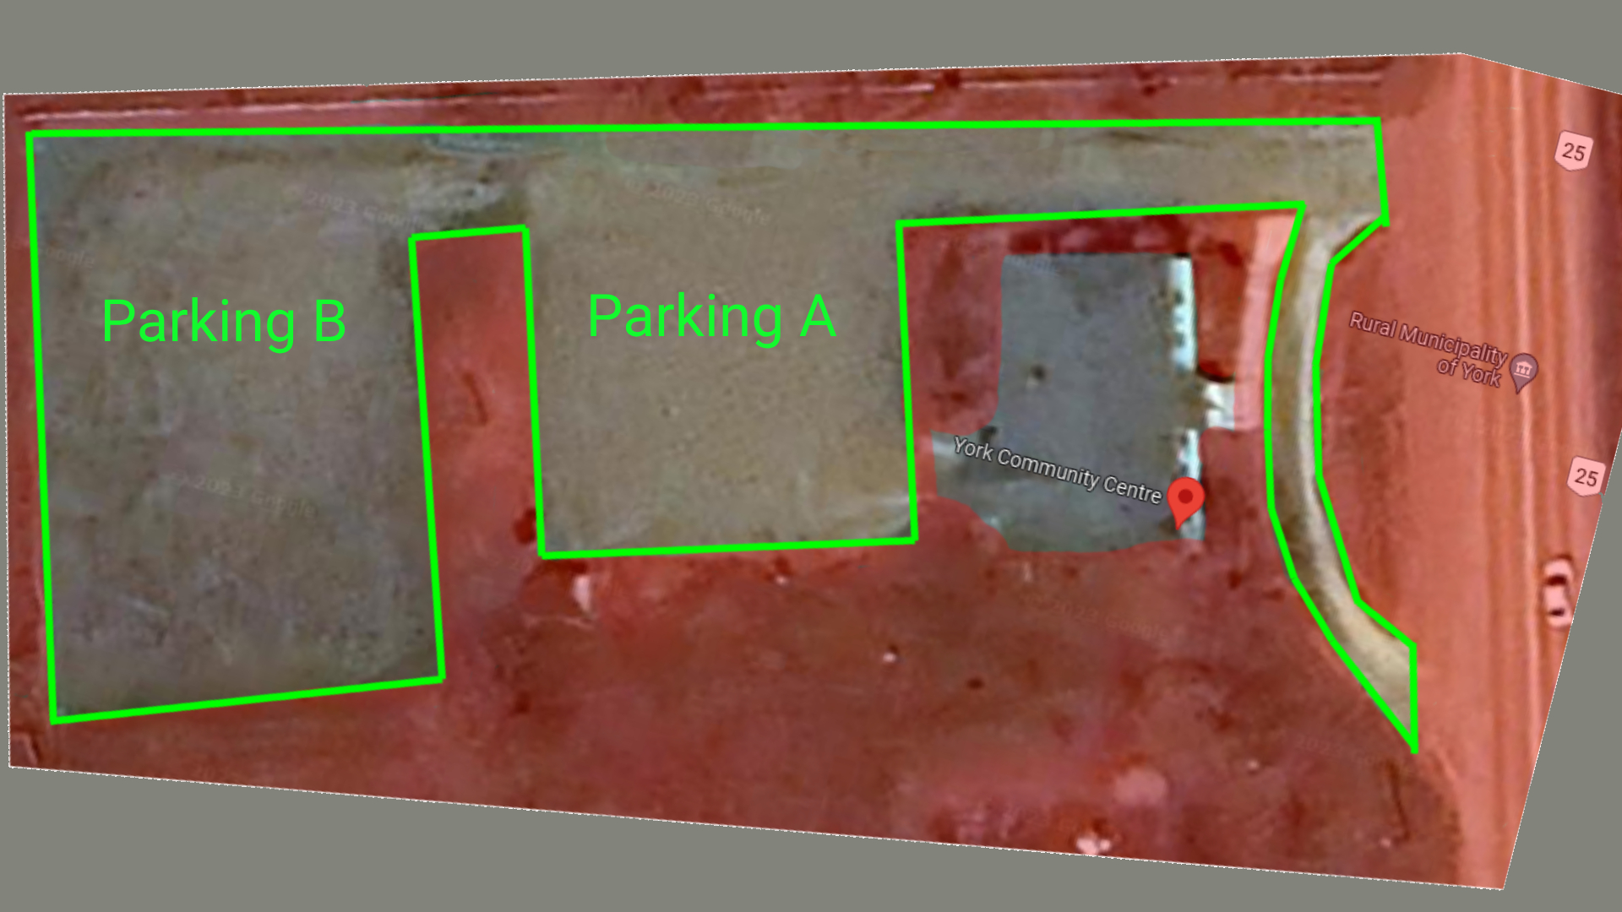

Appendix B
Main Area
Wipe Down & Return Tables To Designated Area
Return All Chairs to Designated Area, Do not block front door.
Floors Swept & Mopped/Wiped if spills present
All Windows Shut & Locked
Sound System turned off and placed back in designated areas.
Kitchen
Counters Wiped Down
Dishes Washed/Dried or placed in Washer and powered on
Dishes & Utensils placed back is designated areas
Garbage & recycle sorted appropriately and disposed of in appropriate bins in parking lot.
Washroom
Toilets Flushed and left unclogged
Garbage removed and disposed of in appropriate bins
Washroom left tidy (no garbage left, counters tidy, Taps off, etc.)
Final
All lights turned off
All additional outside doors are locked
Main door locked upon departure

The Renter Signature: _____________________________

Hall Representative Signature Upon Approval: _______________________

